Halley User Manual

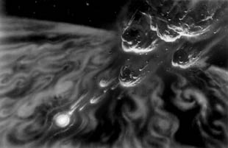

Team Oort Cloud:

Jonathan Moore

Joanna Lewis

David Phillips

TABLE OF CONTENTS

PAGE

Introduction – 2

Welcome Message – 3

Getting Started – 4

Menus – 5

File – 5

Sensor – 5

Robots – 5

Help – 5

Understanding the Graph – 6

Movement – 6

Message Box – 7

Switching Robots – 8

Resetting the Robots – 8

Diagnostics – 9-12

Sensor Picture Reference – 11

Battery Life Meter – 12

Technical Issues – 13

Error Messages – 14-15

Introduction

“One small step for man, one giant leap for mankind,” these famous words will once again be heard on the moon’s surface for NASA plans to implement another moon landing. First however, testing sites need to be evaluated by moon rovers that will collect information pertaining to human and landing craft safety. Team Oort Cloud has been issued the challenge of creating a program to control, monitor, and prompt maintenance of six robots that will be going to the moon. The program will need to collect data on the moon’s temperature, radiation, slope, and compressibility in each individual area of the six robots. Sensor’s for all these data types needs to be monitored and fixed when broken in each robot. Plus, the battery for each robot needs to be monitored and recharged when needed. There needs to be way to review the data collected and any diagnostic concerns. Our program, Halley, has this functionality along with a pleasant interface and user friendly controls.

Team Oort Cloud

Welcome Message

When first opening Halley, you will be greeted by this message:

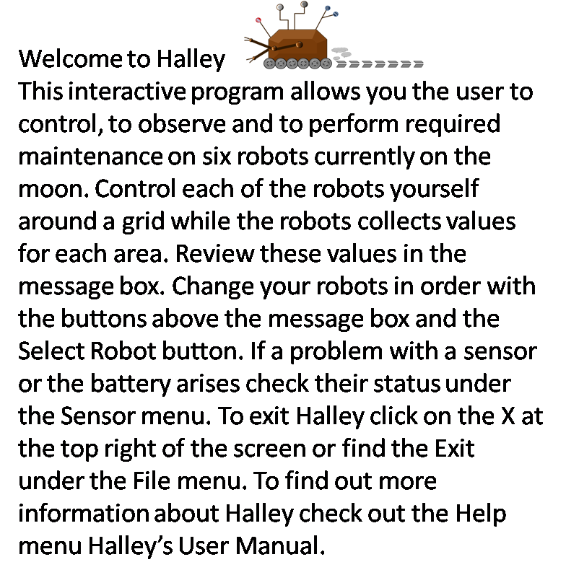

This message is meant to help you when first operating this program. It tells you the basic commands and functions the program allows. To exit this message simply choose Robot 1 and press the “select robot” button to your right. After this the program will start. If you get lost this user manual should answer any questions.

Getting Started

After seeing the Welcome Message and selecting Robot 1 these are the actions a user may take and see in their operation of the program.

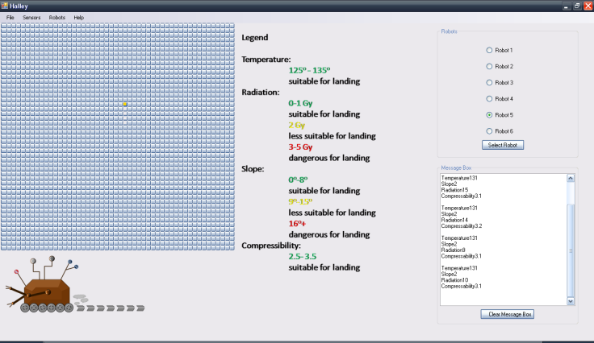

Menu

Robots 1-6

The Select Robot button

Map/Grid/Graph

Message Box

* The user must put the rover on the map and begin navigating it around the map with the arrow keys on the keyboard. (See Understand the Graph on page 6 for more details)
* The user may also decide to check up on any sensors of any robot in the Sensor menu at the top. (See Diagnostics on pages 9-12 or Menu on page 5 for more details)
* If the user decides to navigate the map, the values for Temperature, Radiation, Slope and Compressibility will begin to appear in the message box. (See Message Box on page 7 for more details)
* The user may change robot by clicking the next in order and pressing the “select robot” button (See Switching Robots on page 8 for more details)
* The user may choose to look at the Help menu which will take the user to this user manual. (See Menu on page 5 for more details)
* The user may exit through the File menu or the X and the top right most corner. (See Menu on page 5 for more details)

Menu

The menu for Halley is located at the top of the program. 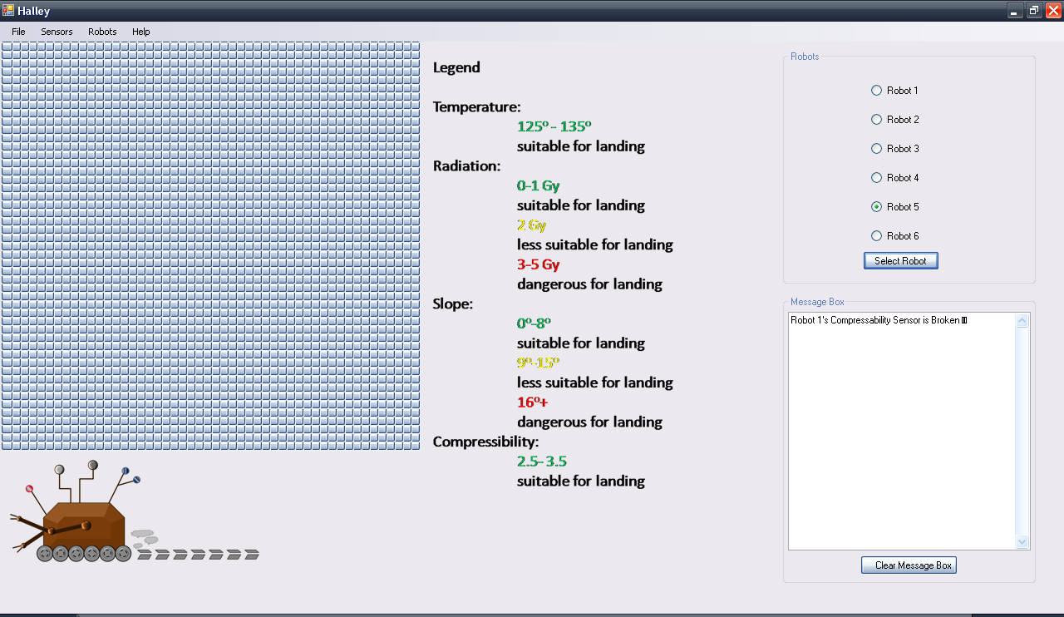

File

The File menu has the option to Exit the program

Sensors

The Sensor menu has all of the options for checking diagnostic information (See Diagnostics on pages 9-12 for more detail)

Robots

The Robots menu has the command for shutting down the robots (when on robot 6) so a new run through of the program may begin. (See Switching Robots on page 8 for more detail)

Help

The Help menu will store an About for the program. This is another overview on how to operate the program. Contents under the Help menu is where this user manual is stored for reference.

Understanding the Graph

At the beginning cycle for each robot the graph is drawn from the left side of the program screen. The graph is a 50X50 grid representing the lunar surface for the robots to navigate.



Movement

Movement in Halley is all manual control. Place the current robot on any point in the graph and direct it using the arrow keys on your keyboard. This picture shows a robot that has moved up four spaces north.

Message Box



* The message box is located in the lower right corner of the program. In the message box you will be able to see the data readings for each space that is visited by the robot.

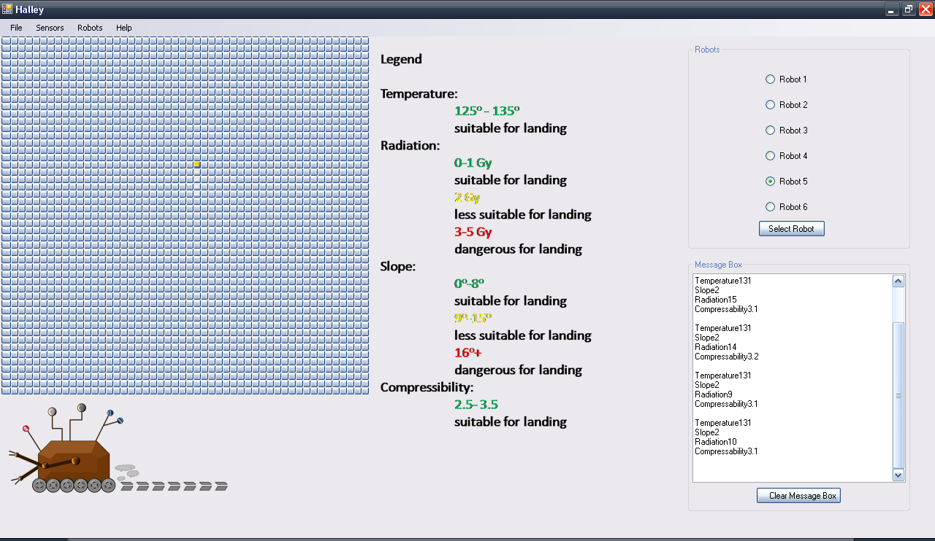

* Also in the message box the user will be able to see any data that has been recorded from any area visited on the grid. The message box will also show error messages or any other technical issues that may arise.

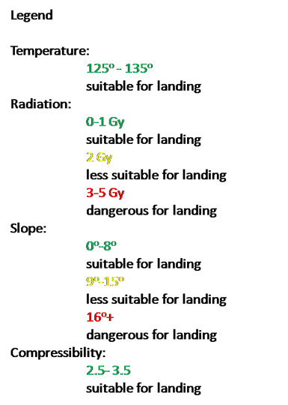

* To understand the Message Box the user should use the legend to the left of the Message Box. The Legend will tell the user what values of Temperature, Slope, Radiation, and Compressibility are safe for human landings.

Switching Robots

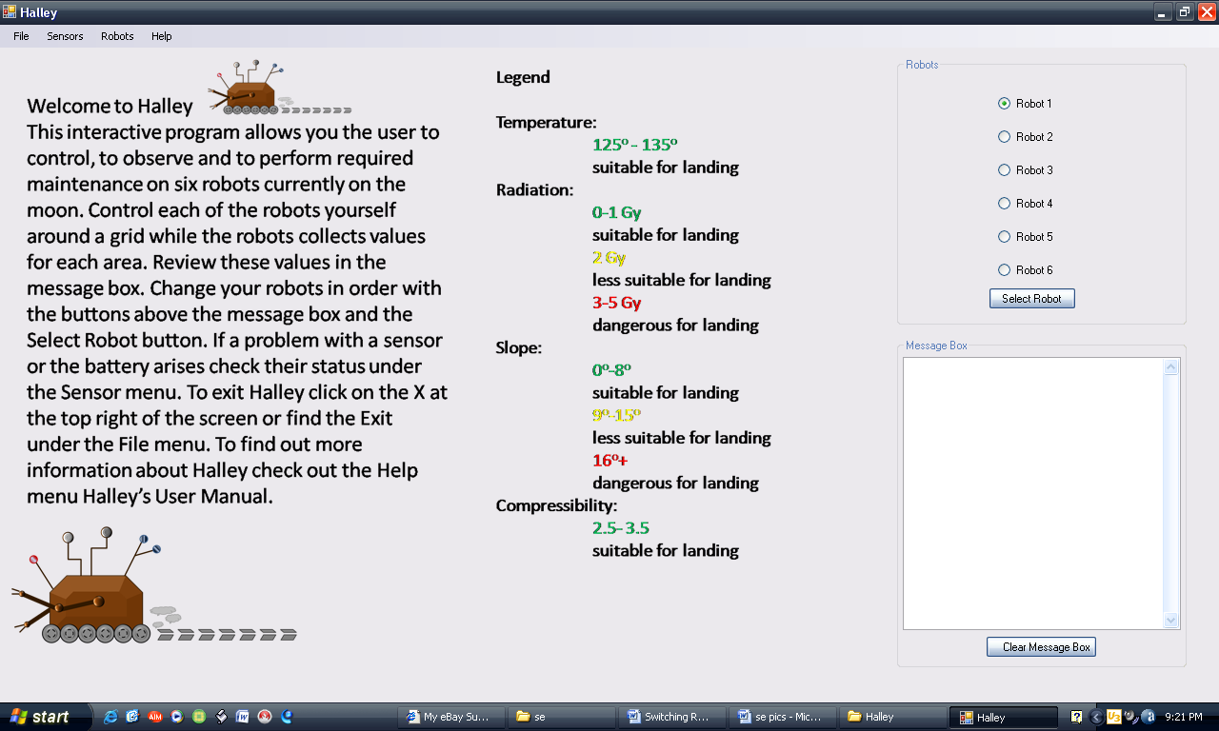When switching robots the user must start on robot one and then proceed to switch through the robots in **NUMERICAL** order. This must be done to ensure that the program runs efficiently.

* Select robot 1 by clicking the radio button
* Then click the Select Robot button located below the robots choices and this will get the robots started.

Resetting the Robots

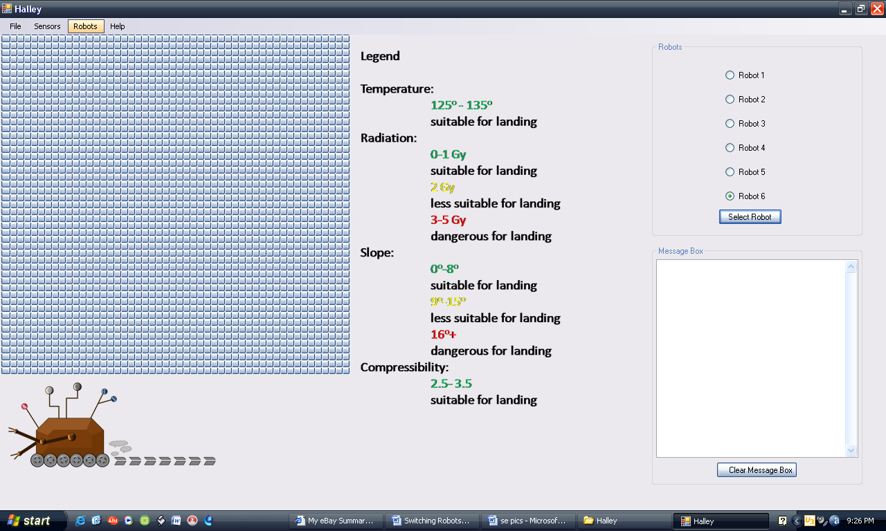Once the user has finished going through the robots and has completed their tasks using robot 6 they must shutdown and restart the robots.

* To do this the user needs to go to the robots tab.

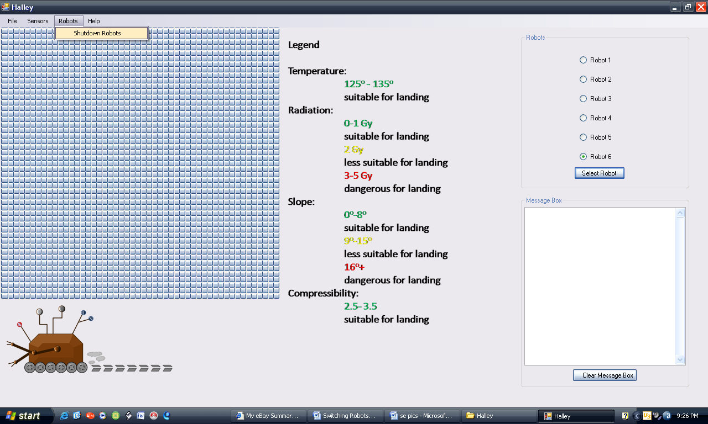

* Now select shutdown robots and this will allow you to start the process over again.

Diagnostics



* There are five diagnostics that need to be monitored on all robots. These diagnostics are the Battery Life, Compressibility, Radiation Level, Slope, and Temperature. All of these can be accessed by clicking on the Sensors Tab at the top of the program.

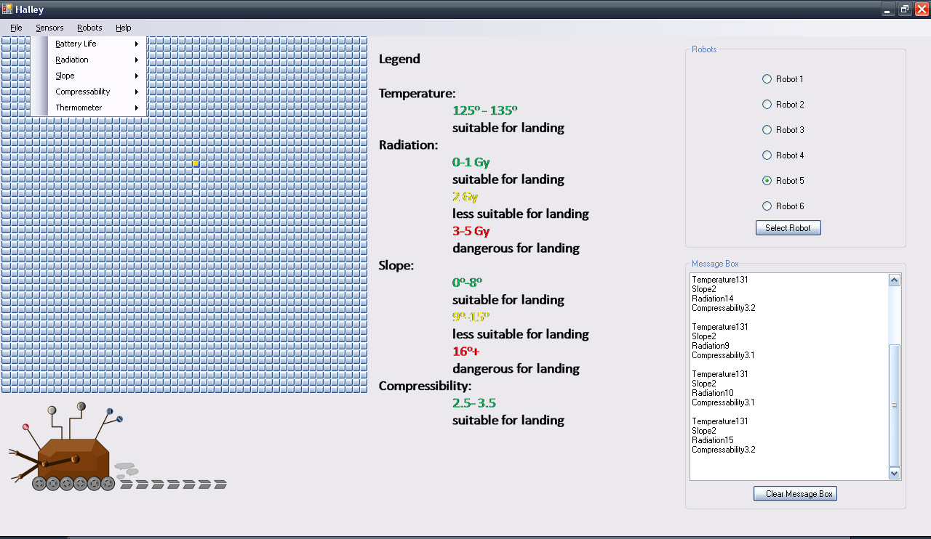

* Once you click on the tab you will get a menu that looks like this:

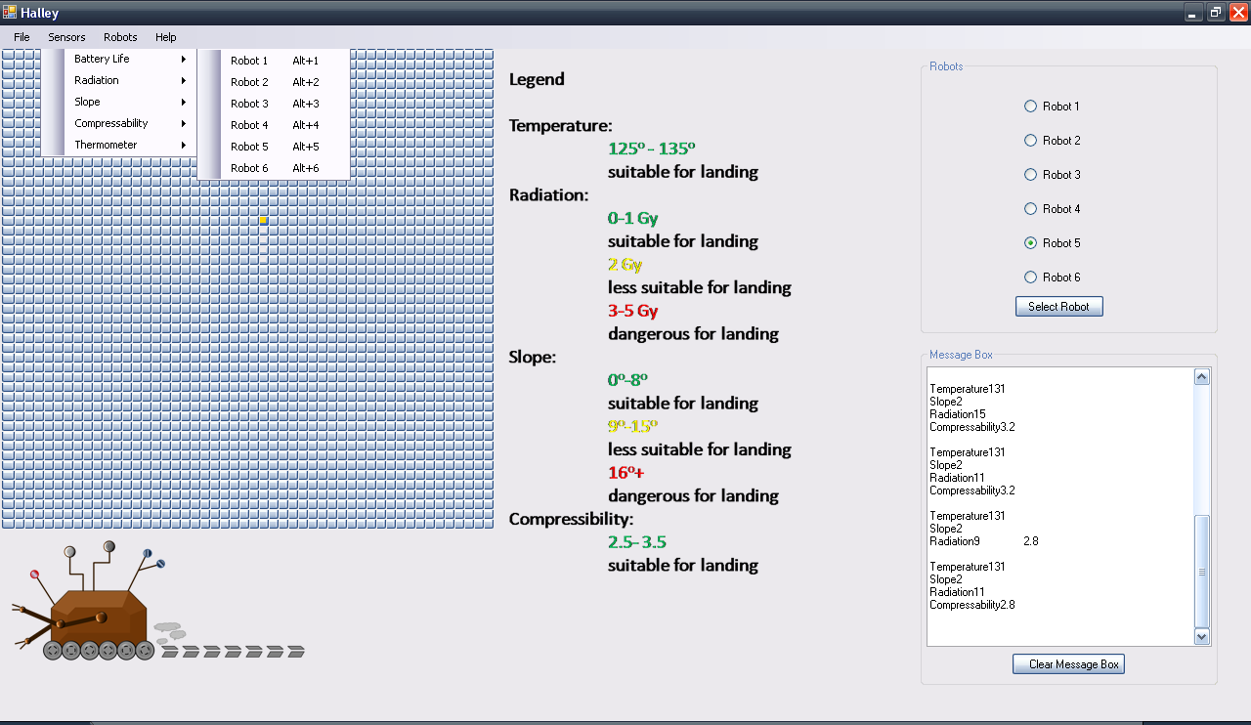

* From here you can select which diagnostics you want to check and then just click on the appropriate robot. You can also repair any sensors that quit working from this screen also.
* If a sensor quits working you will access the sensors just as if you were checking the status of a sensor. A message will be displayed in the message box stating which sensor needs to be addressed.

Once you select the diagnostics you want you will see a picture that represents each diagnostics. These pictures represent the current conditions of the sensors.

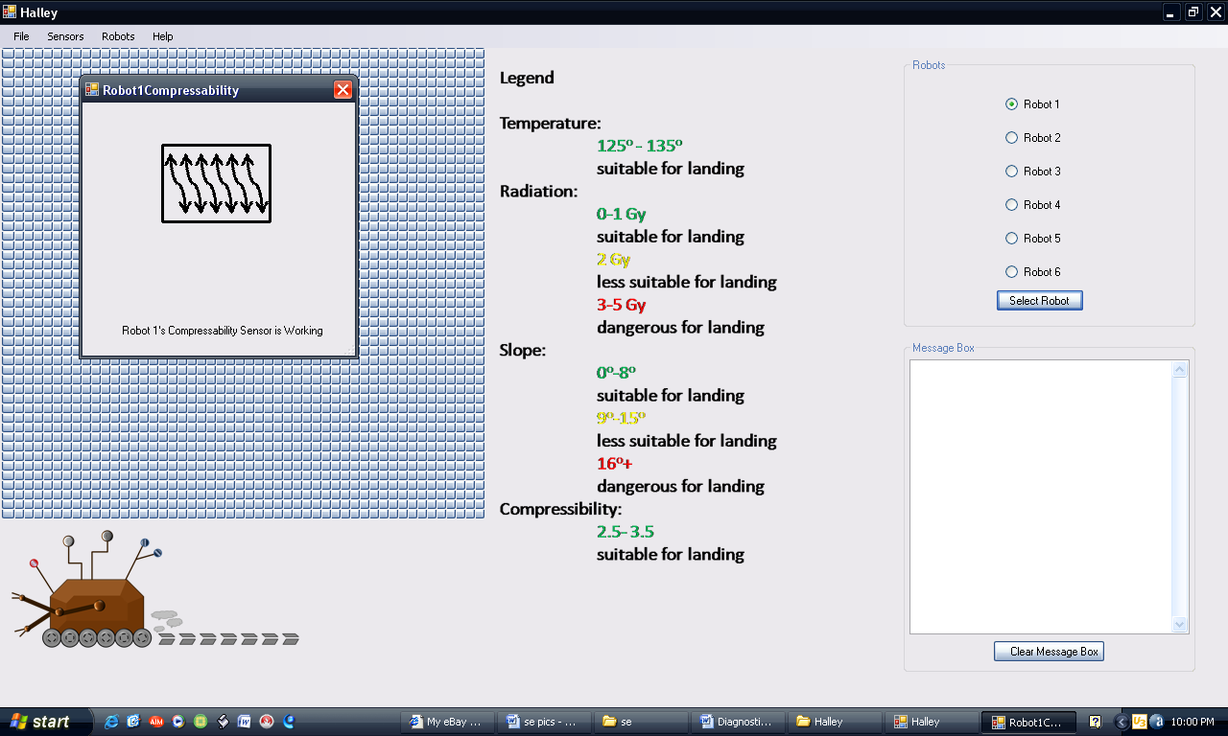

* If there is nothing wrong with the sensor it will look like the picture to the right.

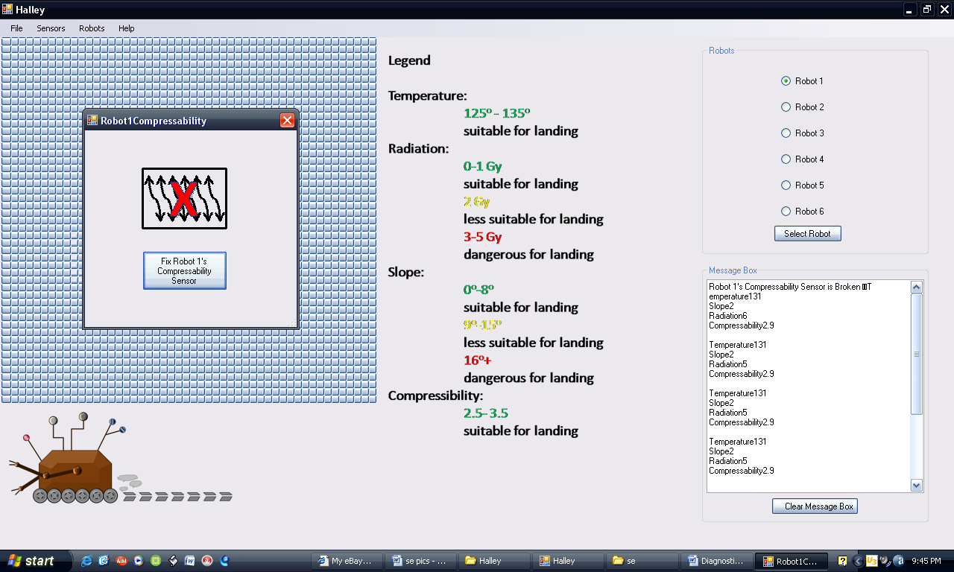

* If there is a red X on the picture then the sensor is currently not working and it needs to be fixed. You can do this by clicking on the Fix Robot button.

Sensor Picture Reference

Compressibility Sensor

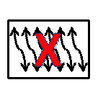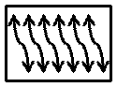

Radiation Sensor



Slope Sensor

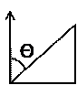

Thermometer



Battery Life Meter

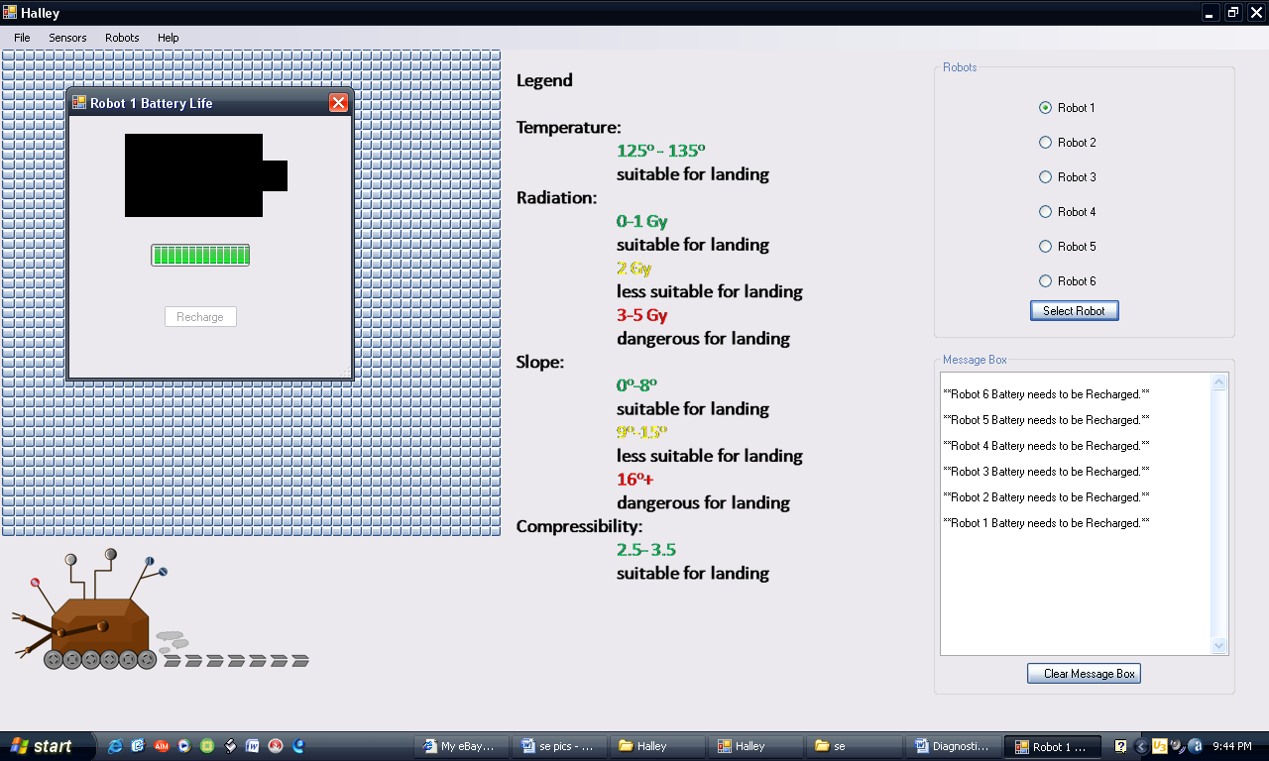

* To verify of the battery is charged you can select it from the Diagnostics menu and the picture should look similar to the one represented to the right.

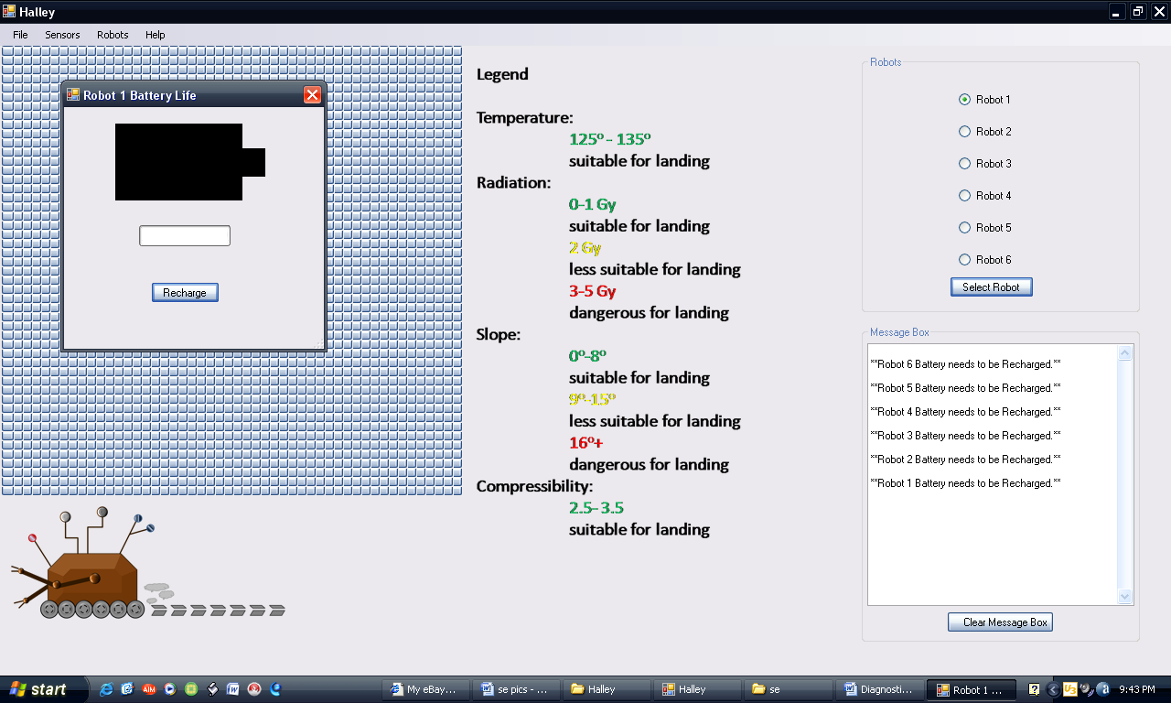

* If the battery needs to be recharged then you will see the picture to the right. To recharge it click on the recharge button.

Technical Issues

These robots like all electronic devices could possibly have technical issues. There are a few things to look out for that need to be addressed if issues occur. Some possible problems that can be addressed are as follows:

* A technical issue with the sensors might occur, an object might impede the mobility of the robots, memory might get filled up, or battery might die and not be able to recharge
* Any error that might occur might not get transmitted to user to inform them of the issue.
* The sensors that are used to gather the required information might malfunction and not be able to gather any data.
* Data gathered might not be able to be sent to NASA to be analyzed.
* Robots might be out of range and location might not be immediately known.
* User’s controls over the robot might not be accurate or functioning
* The robot might get fixed onto one location and unable to alter course
* If course is altered, the data collected might not get sent to NASA or the data might not get collected properly.
* Important messages regarding the robots might not get sent to the message box making the information unavailable to the user.
* Sensors could break and need to be fixed by the user (this is described in the Diagnostics section)

All of these issues can be easily resolved by following the directions in the Diagnostic’s section. If a technical issue arises and there are no specific directions to resolve the problem. Proceed to shutdown the robots and start your process again.

Error Messages

There are a few types of error messages that you might receive. These messages are illustrated below.

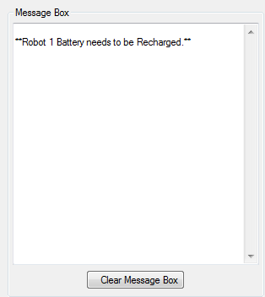

* This message will appear when the battery is low. See Diagnostics on pages 9-12 for more detail.

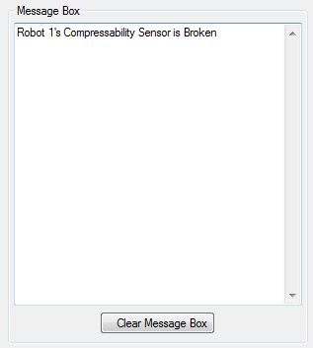

* This message will appear when the Compressibility Sensor is broken. See Diagnostics on pages 9-12 for more detail.

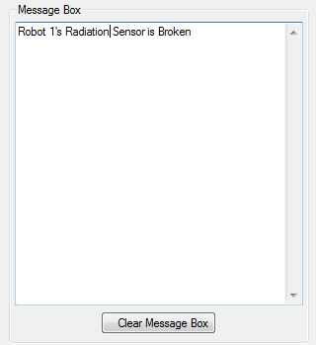

* This message will appear when the Radiation Sensor is broken. See Diagnostics on pages 9-12 for more detail.
* 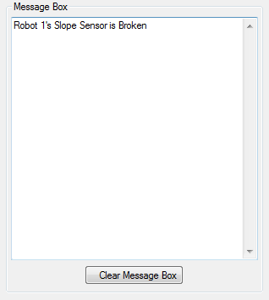This message will appear when the Slope Sensor is broken. See Diagnostics on pages 9-12 for more detail.

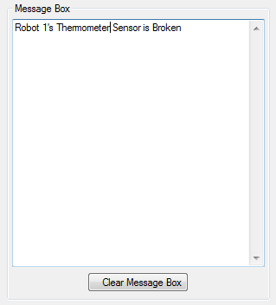

* This message will appear when the Thermometer is broken. See Diagnostics on pages 9-12 for more detail.